I don’t like eConsult

Why should I?

The Boundary House Patient Participation Group have heard from lots of patients who don’t like eConsult. Here’s our take on it:

🩺 eConsult – What You Need to Know
eConsult is a digital service that allows patients to send a consultation request online to their GP practice. It is designed to provide a convenient way for patients to seek medical advice, request prescriptions, or get help with common health concerns without needing to visit the surgery in person to make an appointment.
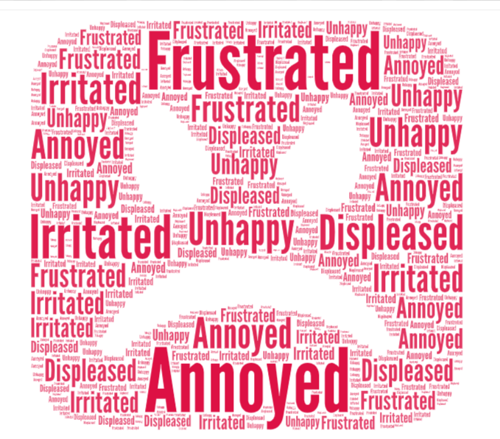
But so many patients dislike having to use eConsult. They know that they want an appointment to see the GP and eConsult just makes the process more difficult. It’s almost as though it is trying to stop us getting an appointment. The tone of the questions isn’t necessarily very friendly, and there are so many of them! Surely they don’t need to know so much? We can tell the Doctor all of the details at the surgery, can’t we?
✅ What is eConsult?
- Required by the NHS – all GP practices must use a system like this.
- A secure online service to contact your GP practice.
- Lets you request advice, prescriptions, or appointments without visiting the surgery.
🌟 Why Use eConsult?
- Quicker care: You may get a phone call, video consultation, prescription, or referral without waiting.
- Right person, right time: Your request is directed to the GP, nurse, pharmacist, or specialist best suited to help.
- No 8am rush: Avoid long phone queues and unnecessary trips to the surgery.
- Convenient: Complete at your own pace on a smartphone, tablet, or computer.
- Better information: Your answers help doctors and specialists understand your needs straight away.
⚖️ Common Concerns
- The questions can feel long or unfriendly.
- It may seem like a barrier to getting an appointment.
- But the detail helps staff triage fairly and ensures urgent cases are prioritised.
💡 Key Takeaway
eConsult is designed to make healthcare fairer, faster, and more efficient. It helps patients and staff work together so everyone gets the care they need in the right way.
Check out a video that explains eConsult - click here.
eConsult is not for every patient. There are some patients who cannot use eConsult and that is fine. Those who cannot use eConsult can call or visit the surgery and a receptionist will offer to do an eConsult Lite. They will then go through a shortened version of the eConsult form so that it can be submitted for triaging.
eConsult should not be used for emergencies. In an emergency seek advice from the relevant urgent care service (e.g. 999, A&E, Urgent Care Centre or NHS 111 helpline).

